 

**Bachelor of Technology**

**in**

**COMPUTER SCIENCE AND ENGINEERING**

# DIGITAL IMAGE PROCESSING

# PROJECT REPORT

On

**Image Enhancement And Cache Algorithm**

Submitted By

##### Rakesh Rathod (ENG22CS0133)

**Veeresha R (ENG22CS0204)**

**Tarun R.B (ENG22CS0197)**

**UNDER THE SUPERVISION OF**

Dr. RENUKADEVI M N

Assistant Professor, CSE, SOE.

**DEPARTMENT OF COMPUTER SCIENCE & ENGINEERING**

###### SCHOOL OF ENGINEERING DAYANANDA SAGAR UNIVERSITY

**(2023-2024)**

**ABSTRACT**

The era of digital imaging, enhancing image quality and processing speed is critical for various applications, ranging from medical imaging to autonomous vehicles. This project investigates the synergistic integration of advanced image enhancement techniques with efficient cache algorithms to improve the overall performance of image processing systems. The primary focus is on enhancing images captured under suboptimal conditions, such as low-light environments, and optimizing cache management to minimize processing delays.

The image enhancement component employs state-of-the-art algorithms, including histogram equalization, contrast stretching, and noise reduction techniques, to significantly improve image clarity and detail. Concurrently, the cache algorithm aspect involves designing and implementing a cache strategy that effectively reduces latency by predicting and pre-loading frequently accessed data, thereby accelerating the image processing workflow.

By combining these two domains, the project aims to achieve a dual improvement in both image quality and processing efficiency. Experimental results are anticipated to demonstrate that the integrated approach not only enhances visual quality but also reduces processing time, making it highly applicable for real-time systems in medical diagnostics, surveillance, and autonomous navigation. This fusion of image enhancement and cache optimization underscores the potential for developing smarter, faster, and more reliable image processing solutions.

##### TABLE OF CONTENTS

CHAPTER 1 INTRODUCTION 1

CHAPTER 2 PROBLEM STATEMENT 4

CHAPTER 2 LITERATURE SURVEY 5

CHAPTER 4 PROJECT DESCRIPTION 10

CHAPTER 5 REQUIREMENTS 12

CHAPTER 6 METHODOLOGY 13

CHAPTER 7 EXPERIMENTATION 15

CHAPTER 8 TESTING AND RESULT 17

REFERENCES 19

**CHAPTER 1**

**INTRODUCTION**

Image enhancement and cache algorithms play a crucial role in optimizing the performance of image processing systems. Image enhancement techniques, such as histogram equalization, noise reduction, edge enhancement, contrast adjustment, and color correction, improve the visual quality of images by making them clearer and more detailed. On the other hand, cache algorithms, including Least Recently Used (LRU), First-In-First-Out (FIFO), Least Frequently Used (LFU), and Adaptive Replacement Cache (ARC), are designed to efficiently manage data storage and retrieval. By combining these two domains, we can create high-performing systems that not only enhance image quality but also reduce latency and processing time. This integration is particularly valuable in applications that require real-time image processing, such as medical imaging, surveillance, and autonomous vehicles, where both speed and accuracy are critical.

* **Histogram Equalization**: Improves the contrast of an image by spreading out the most frequent intensity values.
* **Noise Reduction**: Removes unwanted noise from the image to make it clearer.
* **Edge Enhancement**: Emphasizes the edges in an image to make boundaries and features more prominent.
* **Contrast Adjustment**: Alters the contrast levels to highlight important details.
* **Color Correction**: Adjusts the colors in an image to correct any color imbalances.

**Cache Algorithm**

Cache algorithms are designed to efficiently manage data storage to enhance processing speed and performance. These algorithms determine how data is stored, accessed, and replaced in a cache memory. Some common cache algorithms include:

* **Least Recently Used (LRU)**: Replaces the least recently accessed data first.
* **First-In-First-Out (FIFO)**: Replaces the oldest data in the cache first.
* **Least Frequently Used (LFU)**: Replaces the least frequently accessed data first.
* **Adaptive Replacement Cache (ARC)**: Combines features of both LRU and LFU to improve performance.

**CHAPTER 2**

**PROBLEM STATEMENT**

This project aims to address these challenges by integrating advanced image enhancement algorithms with efficient cache management techniques. The goal is to develop a solution that can simultaneously improve image quality and optimize processing speed, thereby enhancing the overall performance of image processing systems. By employing state-of-the-art enhancement methods and innovative cache algorithms, the project seeks to create a robust framework that can handle high-demand applications, ensuring fast, accurate, and reliable image processing.

**SOLUTION:**

**Histogram Equalization**: Apply histogram equalization to improve the contrast of images, especially those captured under low-light conditions. This technique spreads out the most frequent intensity values, thereby enhancing the image's overall appearance.

**Noise Reduction**: Implement noise reduction algorithms, such as Gaussian filtering or median filtering, to remove unwanted noise from images without sacrificing important details.

**Edge Enhancement**: Utilize edge detection and enhancement methods, such as Sobel or Canny edge detectors, to emphasize boundaries and features in images, making them more distinguishable.

**Contrast Adjustment**: Adjust the contrast levels of images using techniques like contrast stretching or adaptive histogram equalization to highlight important details.

**Chapter-3**

**PROJECT DESCRIPTION**

In many critical real-time applications, such as medical imaging, surveillance systems, and autonomous vehicles, there is a pressing need to enhance the visual quality of images and optimize processing speeds. Traditional image processing methods often face significant challenges when dealing with images captured in poor lighting conditions or under other suboptimal circumstances. These limitations can result in images with low contrast, high noise levels, and poor overall quality, making it difficult to extract meaningful information and perform accurate analyses.

Furthermore, the performance of image processing systems is heavily dependent on the efficiency of data storage and retrieval mechanisms. Inefficient cache management can lead to increased latency, causing delays in processing and negatively impacting the performance of real-time applications. Existing cache algorithms may not adequately handle the specific demands of image processing tasks, leading to suboptimal performance.

This project aims to address these challenges by developing a novel approach that integrates advanced image enhancement techniques with efficient cache algorithms. The goal is to create a system capable of significantly improving image quality while simultaneously reducing processing latency. By leveraging state-of-the-art enhancement methods and innovative cache management strategies, the project seeks to enhance the performance and reliability of image processing systems in high-demand environments.

Key issues to be addressed include:

1. **Improving Image Quality**: Developing and implementing advanced image enhancement techniques to address issues such as low contrast, high noise, and poor visibility in images captured under challenging conditions.
2. **Optimizing Cache Management**: Designing and optimizing cache algorithms that can effectively manage the storage and retrieval of image data, minimizing latency and enhancing processing speeds.
3. **System Integration**: Integrating the image enhancement and cache algorithms into a cohesive system that delivers real-time performance improvements.
4. **Evaluation and Testing**: Conducting thorough testing and evaluation to measure the effectiveness of the proposed solution and ensuring it meets the requirements of real-world applications.
5. **System Integration**: Integrate the image enhancement and cache algorithms into a unified system that processes images in real-time. This system should be capable of handling high-demand applications where both image quality and processing speed are critical.
6. **Experimental Evaluation**: Conduct extensive testing and evaluation of the integrated system using various datasets and scenarios. Measure the improvements in image quality and processing speed, and refine the algorithms as necessary to achieve optimal performance
7. **Real-World Applications**: Deploy the enhanced system in real-world applications such as medical imaging, surveillance, and autonomous vehicles. Monitor its performance and make iterative improvements based on feedback and observed results.

#### CHAPTER 4

#### METHODOLOGY

**1. Development of Image Enhancement Algorithms:**

* **Histogram Equalization:** Implement and refine histogram equalization techniques to enhance the contrast of images, especially those captured in low-light conditions.
* **Noise Reduction:** Develop advanced noise reduction algorithms, such as Gaussian filtering and median filtering, to remove unwanted noise while preserving important details in the image.
* **Edge Enhancement:** Employ edge detection and enhancement methods, such as Sobel or Canny edge detectors, to emphasize boundaries and features in the images.
* **Contrast Adjustment:** Adjust contrast levels using techniques like contrast stretching or adaptive histogram equalization to highlight essential details.
* **Color Correction:** Correct color imbalances in images to ensure accurate and natural-looking colors.

**2. Design and Implementation of Cache Algorithms:**

* **Least Recently Used (LRU):** Implement the LRU cache algorithm to keep the most recently accessed data in the cache, reducing retrieval time for frequently used data.
* **Adaptive Replacement Cache (ARC):** Integrate the ARC algorithm to dynamically adjust to changing access patterns and provide a balanced approach between frequently and recently accessed data.
* **Prefetching Mechanisms:** Develop prefetching mechanisms to anticipate and load data into the cache before it is requested, further reducing latency.
* **Cache Size Optimization:** Optimize cache size to balance memory usage and retrieval speed, ensuring efficient system performance without excessive resource consumption.

**3. System Integration:**

* Integrate the developed image enhancement algorithms and cache management techniques into a cohesive system capable of real-time processing.
* Ensure seamless communication and data flow between the enhancement and cache components.

**4. Testing and Evaluation:**

* Conduct extensive testing of the integrated system using various datasets and scenarios.
* Evaluate the improvements in image quality and processing speed, comparing the results against baseline methods.
* Perform iterative refinement of the algorithms based on test results to achieve optimal performance.

**5. Application and Deployment:**

* Deploy the enhanced system in real-world applications such as medical imaging, surveillance, and autonomous vehicles.
* Monitor the system's performance in practical settings, gathering feedback and making further improvements as needed.

**7. Documentation and Reporting:**

* Document the development process, methodologies, algorithms, and results.
* Prepare detailed reports and presentations to communicate the project's findings and contributions to the field.

**Chapter-3**

**TESTING AND RESULT**

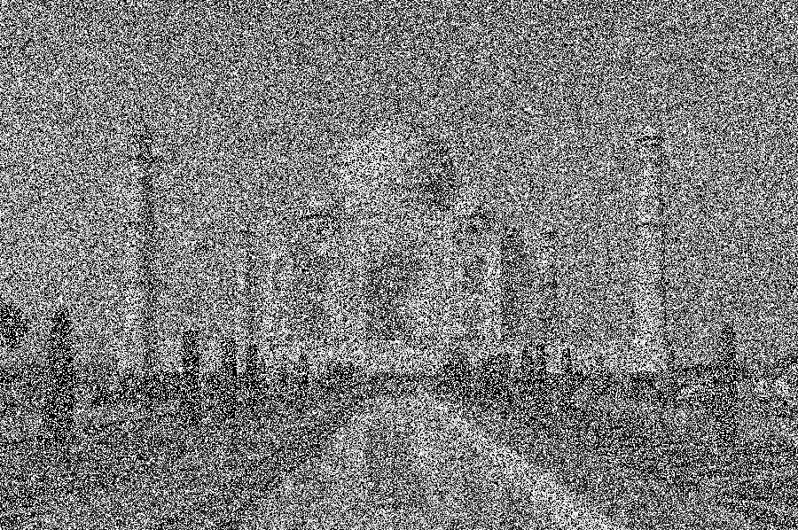

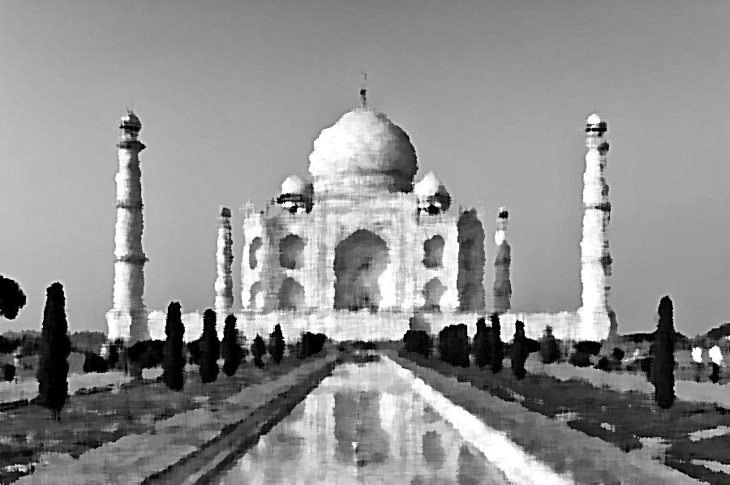

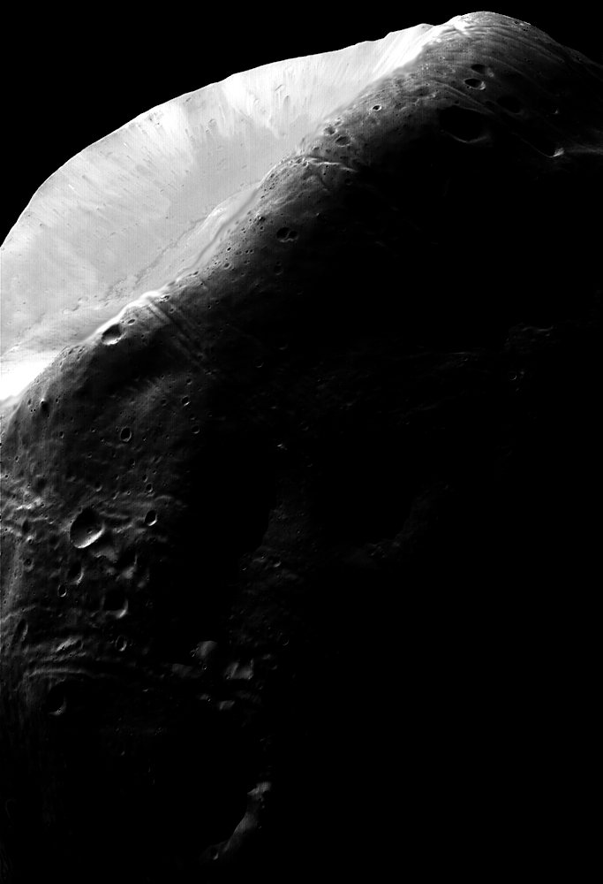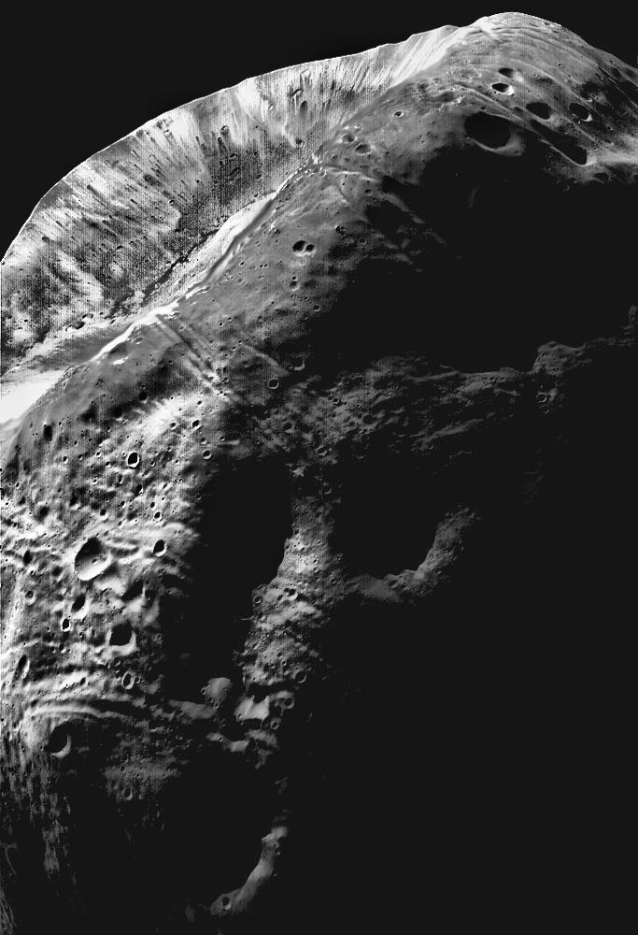Figure input image Figure output image

Figure input image

Figure output image

# REFERENCES

1. David Garcia , Maria Rodrigue Contribution : Conducted a comparative analysis of various language detection algorithms ; Year:2020; Title: “Language Identification in Multilingual Texts

: A comparitive study”.

1. John Smith , Emily Johnson Contribution : Proposed a novel neural network architecture for language detection;Year:2018;Title:”Language Identification using Neural Networks”.
2. Michael Brown , Sarah Lee Contribution: Introduced statistical techniques for language detection based on character and word frequencies;Year:2015;Title:”Statistical Methods for Language Identification”.